|  |  |
| --- | --- |
| TALLINN UNIVERSITY OF TECHNOLOGY | |
| School of Information Technologies | |
|  | |
|  | |
| Karl Oskar Anderson 185611IADB | |
| Creating a food ordering environment | |
| Course work | |
| Supervisor: | Andres Käver |
|  |  |
|  |  |
|  |  |
|  |  |
|  |  |
|  |  |
|  |  |
|  |  |
|  |  |

**Author’s declaration of originality**

I hereby certify that I am the sole author of this thesis. All the used materials, references to the literature and the work of others have been referred to. This thesis has not been presented for examination anywhere else.

Author: Karl Oskar Anderson

22.02.2020

Table of contents

**Author’s declaration of originality** 2

Table of contents 3

List of figures 4

1 Introduction 5

2 Project 6

List of figures

**Figure 1: ERD – diagraph of the food ordering environment**

1 Introduction

The author noticed the shortcomings of the food ordering environments currently on the market and thus decided to develop his own vision.

The author believes that the design of the project symbolizes a snow-capped mountain top of his university journey. The author respects his own desire to embark upon this wide-eyed journey to emerge in the end feeling tired, slightly crushed, less naive perhaps, but ultimately beaming with accomplishment. Provided he does not find his end on the way that is.

The author prepares a project that he sells to companies operating within the bounds of a particular country, who are primarily engaged in preparing end-user customizable foods like pizza and serving them to customers. All food servicing companies will hereinafter be referred to collectively as restaurants. The project is of interest to companies that are satisfied with this solution and the end customers are private individuals who want to order a seal. In essence the author has a fictional client, business owner X, who wants to create a web service solution for their company Y in order for the company to operate online.

2 Project

Let there be a website www.ZY.ee where company administrators can create their own user accounts. Company administrators have rights to manage descriptions of their restaurants, add food to menus, change menus and change food prices.

Restaurants have a menu; the same menu may be used in different restaurants. When ordering food, the user simply has to choose the restaurant of his choice. Food is divided into categories: pizzas, drinks, desserts etc. Users should not be confused, all foods should be listed on a single page – meaning category is not recursive. One product can only be under one category. The pizzas on the menu are not definitive; the pizzas have a variety of sizes, bases and additional components that the customer specifies on purchase.

The food prices are determined by individual restaurants. The same food may be differently priced in different restaurants. All pizzas have a base price and basic components. The components of the pizza can be modified and added up to a certain limit. It must be possible to add one component to the same pizza several times. Removing the basic components will not reduce the price of the pizza. Basic components can be removed to some extent and new components can be added step by step. The components have a price, but the price of the basic components is included in the basic price of the pizza. Removing the basic pizza components will not reduce the price of the pizza, but you can add more components in place of the removed component. If the added component is more expensive than the removed base component, the difference will have to be paid by the customer; if lower, the customer will still have to pay the basic pizza price.

Meals do not have prices in multiple currencies, but there can be several prices for one meal at a given time. Users belong to customer groups; prices vary for different customer groups. If the user belongs to more than one customer group, the lowest price is assigned to the user. Price will be displayed in gross, net prices will be calculated to receipt by tax.

The customer can add food to their cart. The customer can choose the type of food handover: carryout/dine-in or by courier delivery. When ordering by courier, the customer must specify the delivery address. The address is saved under the user's account so that the food delivered to the same location will not need to be refilled next time. The invoice is issued not to the user but to a person, nevertheless the buying user will pay. The person who receives the food may not be the owner of the user account who paid the invoice. An invoice consists of invoice lines. The invoice lines are not related to the price of food, otherwise the existing invoices will change as the price of the food changes (unless a significantly more advanced solution is used). Invoice rows cannot be changed- they are permanent. Calculating fees or physical limitations of the courier is beyond the scope of this project, we expect the pizzas to arrive free, anywhere and instantaneously.

The invoice can be shared between friends of the user. This is a useful feature for events, where one person is responsible for providing food for a group and compensation is expected. A new share item is created in order to share the invoice. Shared foods come from invoice lines. Manually selecting single invoice rows would not be user friendly, so sharing meals will be generated based on the invoice. Users can share foods with their friends at a percentage and the system calculates how much money that friend owns them. Unallocated foods are the property of the user.

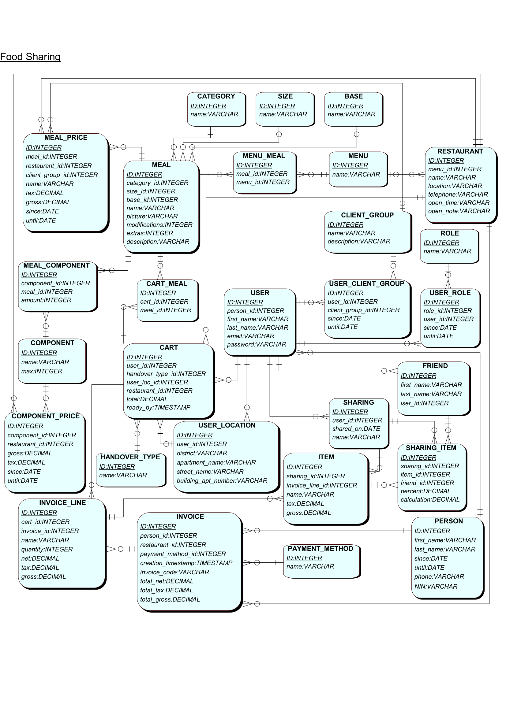

Figure 1: ERD – diagraph of the food ordering environment